3.1 Interpolation and the Lagrange Polynomial

1. Use Lagrange interpolating polynomials of degree one, two, three, and four to approximation of the following:

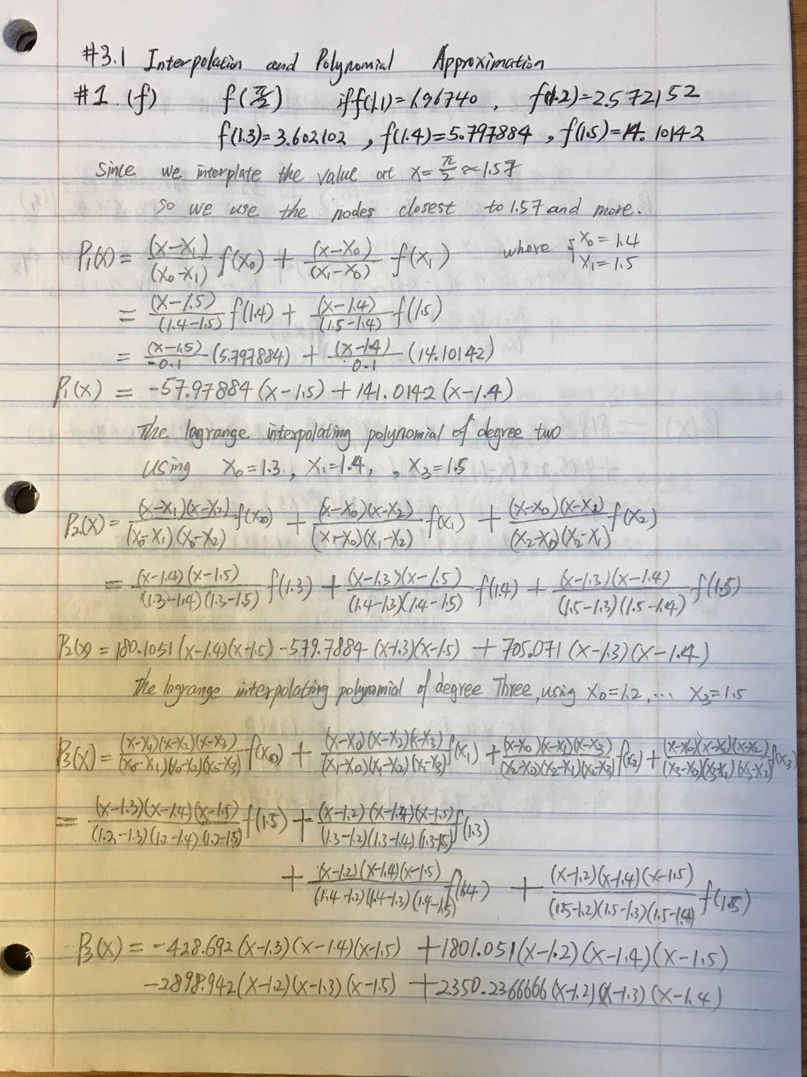

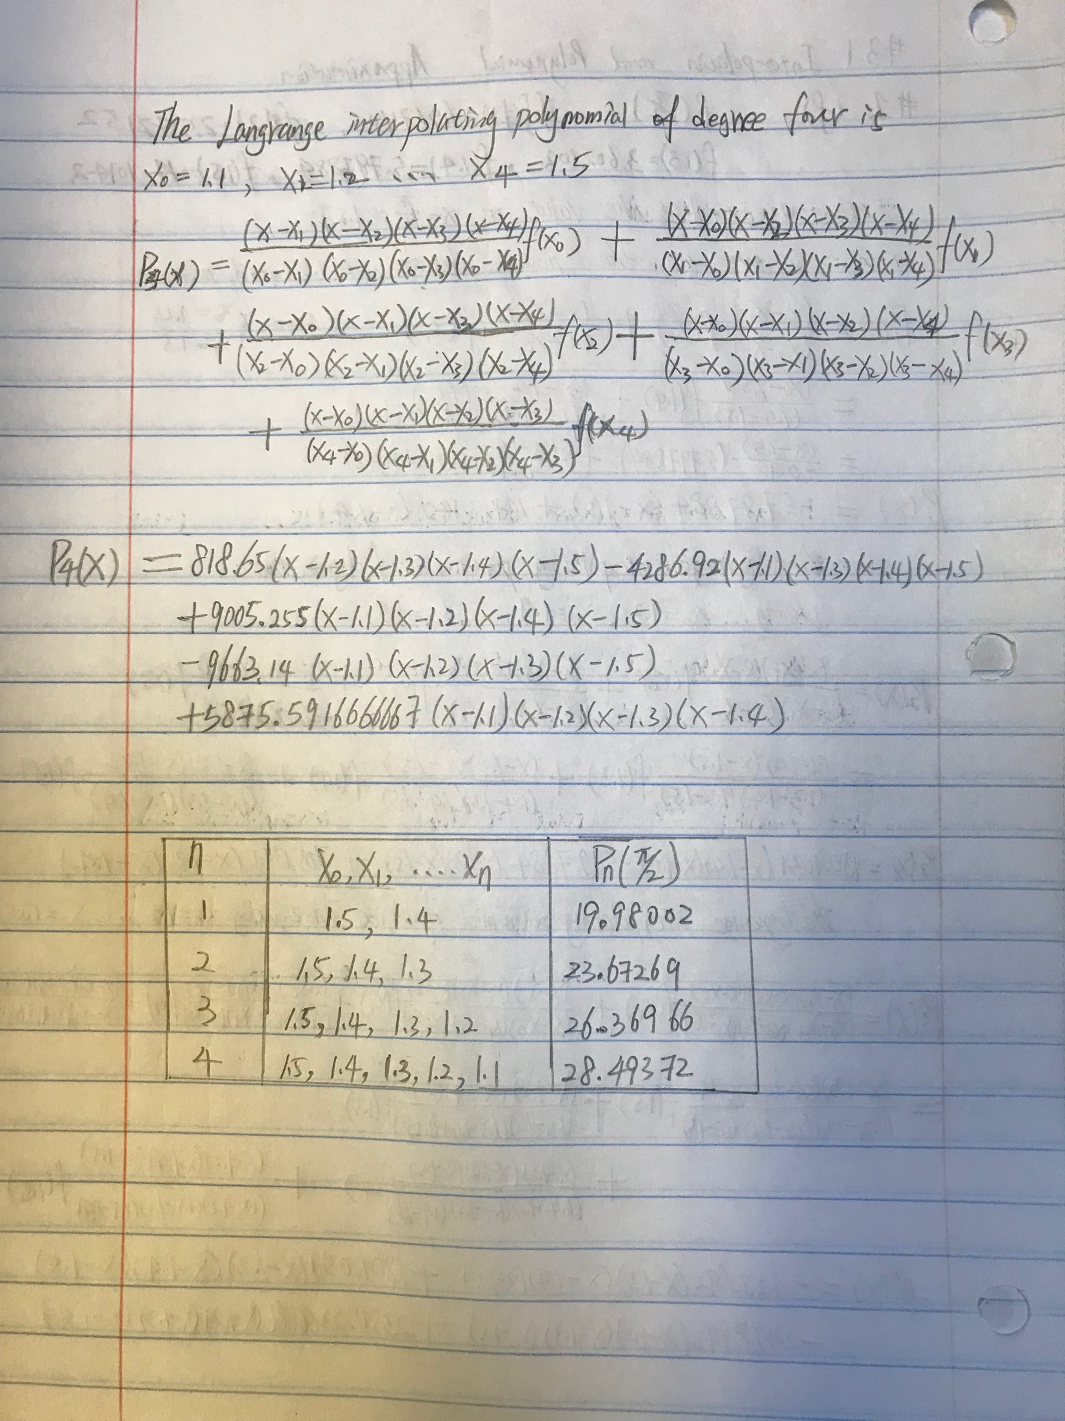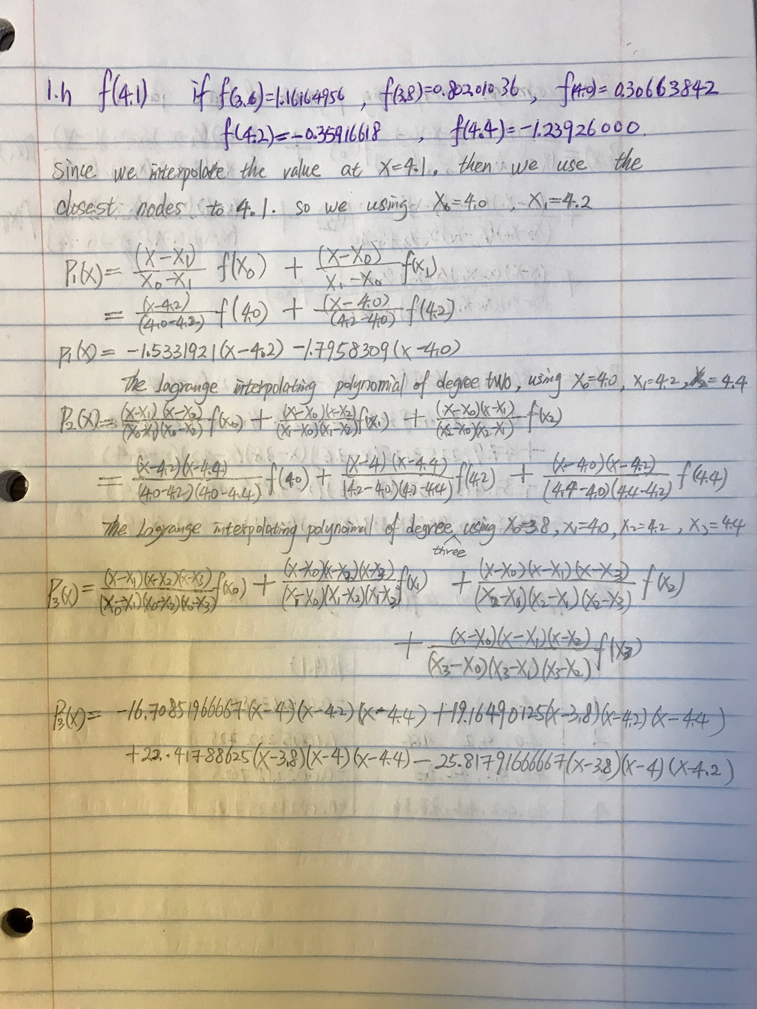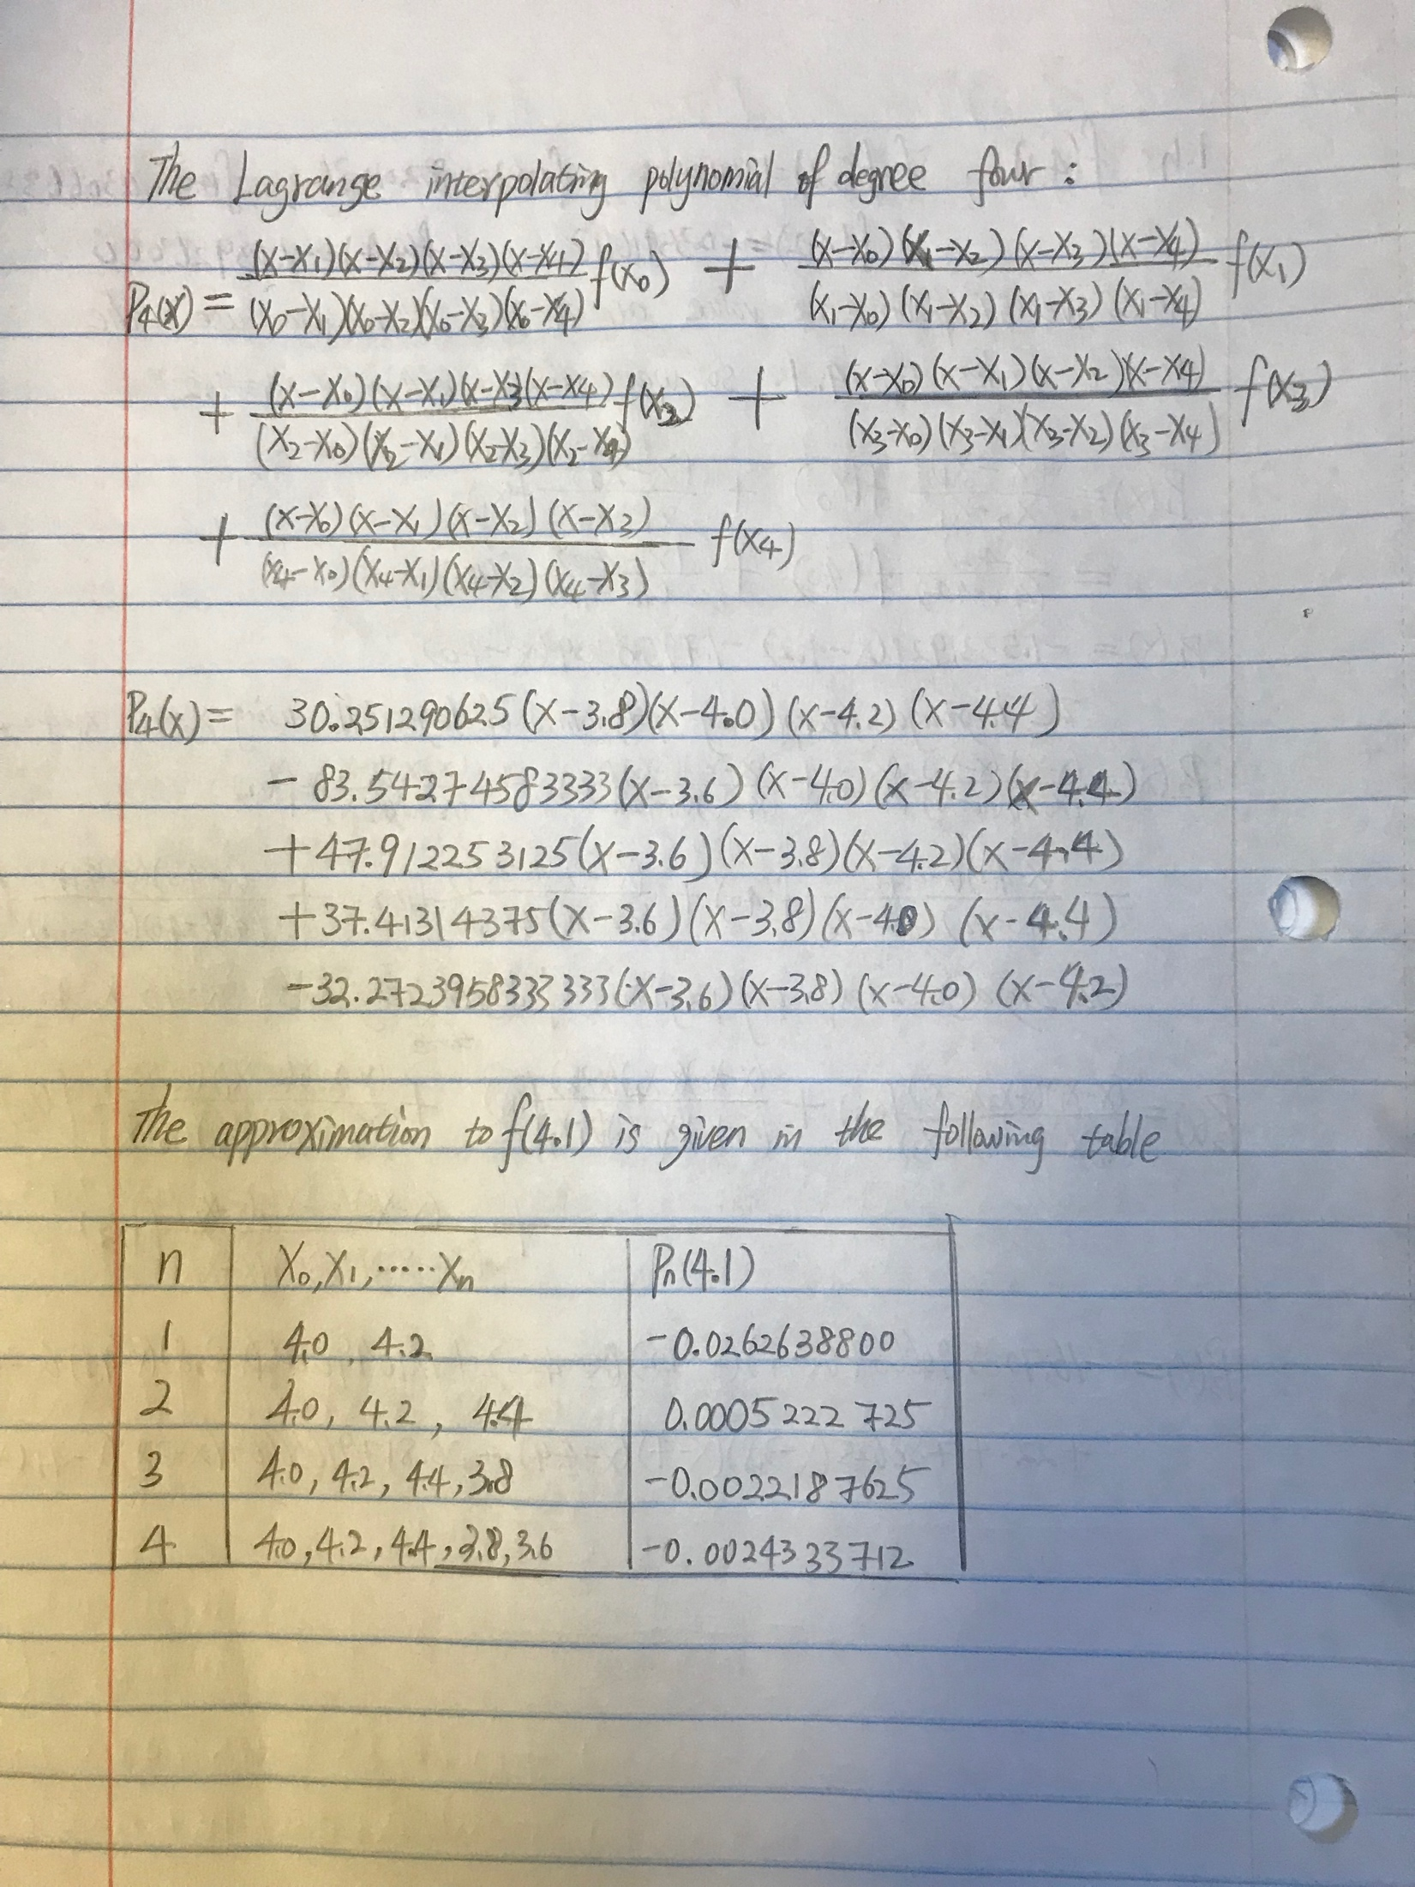

2. Use Neville’s method to obtain the approximations for Exercise 1.

2f.

For degree of one, using node 3 and 4 (the index starts from zero)

> x = (11:15) / 10

> y = c(1.964760, 2.572152, 3.602102, 5.797884, 14.10142)

> A = cbind (x, y)

> neville (A, pi / 2, nodes = 3:4)

$table

[,1] [,2]

[1,] 5.797884 NA

[2,] 14.101420 19.98002

$interp

[1] 19.98002

For degree of two, using node from 2 to 4.

> neville (A, pi / 2, nodes = 2:4)

[1] 2 3 4

$table

[,1] [,2] [,3]

[1,] 3.602102 NA NA

[2,] 5.797884 9.548199 NA

[3,] 14.101420 19.980018 23.67269

$interp

[1] 23.6726

For degree of two, using node from 1 to 4.

> neville (A, pi / 2, nodes = 1:4)

$table

[,1] [,2] [,3]

[1,] 3.602102 NA NA

[2,] 5.797884 9.548199 NA

[3,] 14.101420 19.980018 23.67269

$interp

[1] 23.67269

For degree of two, using all nodes.

> neville (A, pi / 2, nodes = 0:4)

$table

[,1] [,2] [,3] [,4] [,5]

[1,] 1.964760 NA NA NA NA

[2,] 2.572152 4.824339 NA NA NA

[3,] 3.602102 6.391169 8.512627 NA NA

[4,] 5.797884 9.548199 12.244245 14.36873 NA

[5,] 14.101420 19.980018 23.672691 26.36966 28.49372

$interp

[1] 28.49372

(notice: Neville’s method is not useful for writing out the Lagrange polynomial)

+****************************************************************************+

**2h.**

For degree one interpolation uses nodes 2 and 3, because x2 < 4.1 < x3=4.2

> x= (18:22) /5

> y=c(1.16164956,0.80201036,0.30663842,-0.35916618,-1.23926000)

> A=cbind(x,y);A

> neville(A, 4.1, nodes = 2:3)

$table

[,1] [,2]

[1,] 0.3066384 NA

[2,] -0.3591662 -0.02626388

$interp

[1] -0.02626388

For degree two interpolation uses nodes 2 through 4:

> neville(A, 4.1, nodes = 2:4)

$table

[,1] [,2] [,3]

[1,] 0.3066384 NA NA

[2,] -0.3591662 -0.02626388 NA

[3,] -1.2392600 0.08088073 0.0005222725

$interp

[1] 0.0005222725

For degree three interpolation uses nodes 1 through 4:

> neville(A, 4.1, nodes = 1:4)

$table

[,1] [,2] [,3] [,4]

[1,] 0.8020104 NA NA NA

[2,] 0.3066384 0.05895245 NA NA

[3,] -0.3591662 -0.02626388 -0.0049597975 NA

[4,] -1.2392600 0.08088073 0.0005222725 -0.002218762

$interp

[1] -0.002218762

For degree **four** interpolation uses all nodes:

> neville(A, 4.1)

$table

[,1] [,2] [,3] [,4] [,5]

[1,] 1.1616496 NA NA NA NA

[2,] 0.8020104 0.26255156 NA NA NA

[3,] 0.3066384 0.05895245 0.0080526725 NA NA

[4,] -0.3591662 -0.02626388 -0.0049597975 -0.002791052 NA

[5,] -1.2392600 0.08088073 0.0005222725 -0.002218762 -0.002433371

$interp

[1] -0.002433

+****************************************************************************+

3. $Approximate \sqrt{3} using Neville^{'}s method with the function f\left(x\right)=3^{x} and the values x_{0}=-2, x_{1}=-1, { x}_{2}=0, x_{3}=1, x_{4}=2$

Since we know:

$$\sqrt{3}≈1.73, and f\left(0\right)=1, f\left(1\right)=3, so we have to choose a value between 0 and 1 to interpolate.$$

Let the value = 0.5

> x = -2:2

> y=3^x

> A = cbind(x,y)

> neville(A, 0.5)$interp

[1] 1.708333

+****************************************************************************+

7.

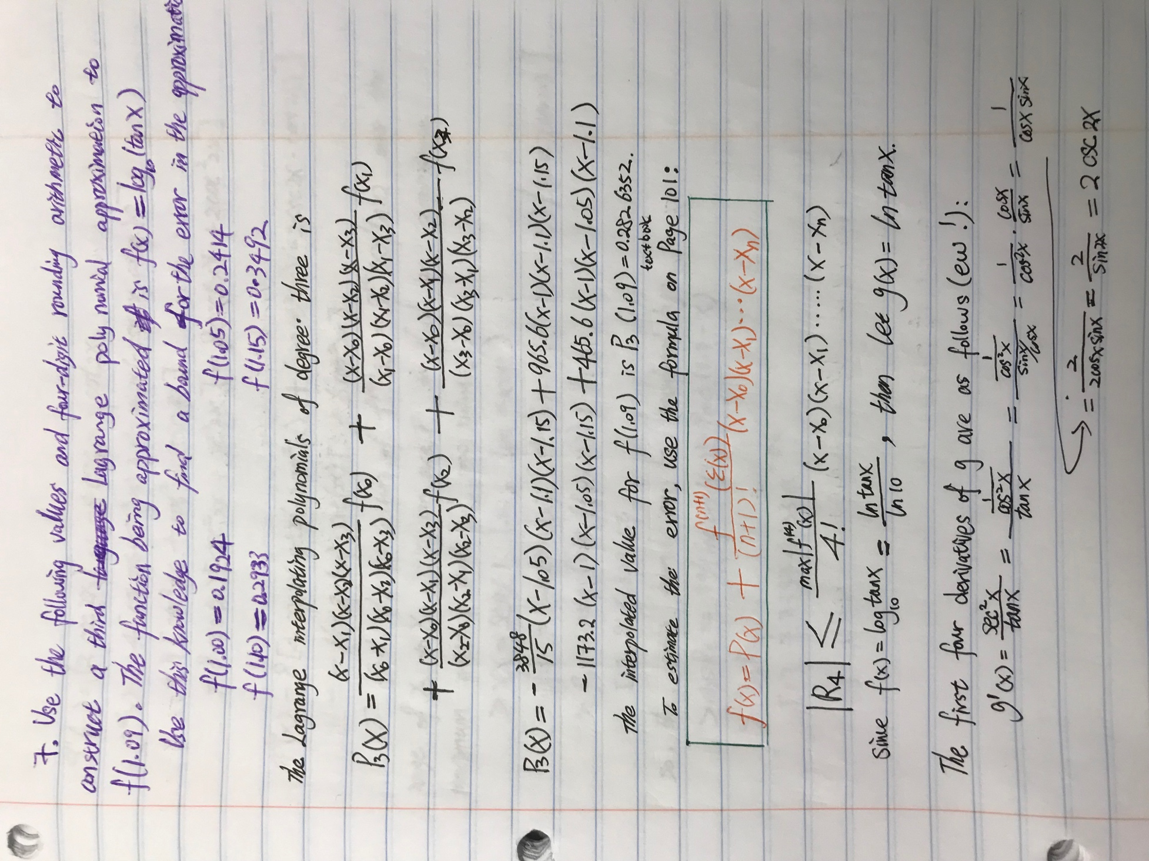

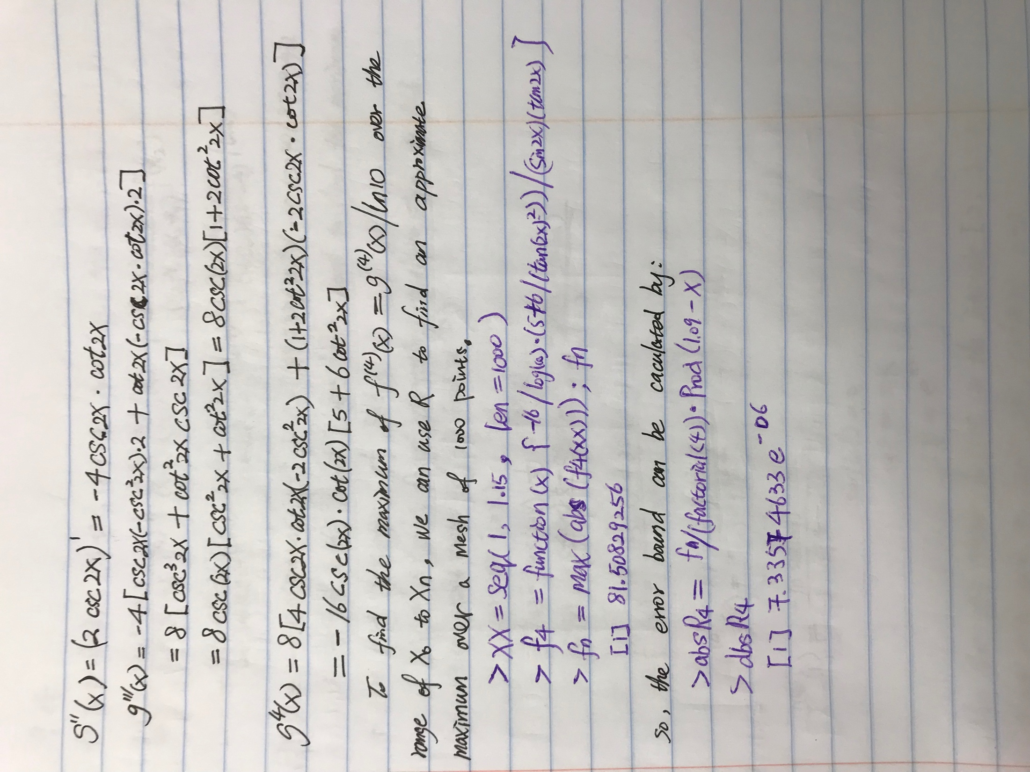

+****************************************************************************+

8. Use Neville’s method and four-digit rounding arithmetic to approximate f(1.09) for the data given in Exercise #7.

> x = 1 + (0:3) * 0.05

> y=c(0.1924,0.2414,0.2933,0.3492)

> A = cbind (x, y)

> neville (A, 1.09)

$table

[,1] [,2] [,3] [,4]

[1,] 0.1924 NA NA NA

[2,] 0.2414 0.28060 NA NA

[3,] 0.2933 0.28292 0.282688 NA

[4,] 0.3492 0.28212 0.282600 0.2826352

$interp

[1] 0.2826352

+****************************************************************************+

9. Construct the Lagrange interpolating polynomials for the following functions and find a bound for the absolute error on the interval [X0 : Xn]

P2(x) = −11.201774381x2 + 3.80821059708x + 1

To find the bound on the error, we need to find the maximum of the third derivative of e2x cos(3x). We will set the fourth derivative equal to zero to find the maximizer (call it p). Thus,

f (4) (p) = −119e2p cos 3p + 120e2p sin 3p = 0

tan 3p =119/120

p = (1/3) tan−1(119/120) ≈ 0.260404695798 ∈ **(0, 0.6)**

If we check the endpoints 0 and 0.6, and compare to p, we find that |f(3)(x)| is maximized at p. We can check this answer using R:

> f3=function(x) { -exp(2*x)*(46*cos(3*x)+9*sin(3*x)) }

> p=1/3*atan(119/120)

> M=abs(f3(p))

> M

[1] 65.6522

> xx = seq(0, .6, len=1000)

> fn = max ( abs(f3(xx)) )

> fn

[1] 65.65217

Thus p = (1/3) tan−1(119/120 is the point reach to max value of |f(3)(x)|.

The only differences are due to choosing a mesh of points, instead of a continuum of points. We’re good.

Next, to maximize the error over the entire interval, we also need to maximize

$$g\left(x\right)=(x-0)\left(x-0.3\right)\left(x-0.6\right)=x^{3}-0.9x^{2}+0.18x$$

$${g^{'}\left(x\right)=3x}^{2}-1.8x+0.18=0$$

$x=\frac{1.8±\sqrt{1.08}}{6}$

Checking the value of the absolute value of g(x) at the end points of the interval and the critical points is as follows:

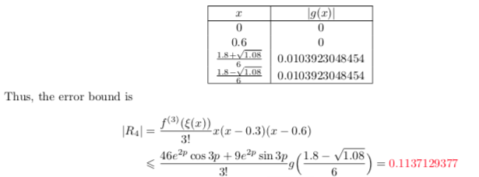

> errorbound = M/6*prod((1.8-sqrt(1.08))/6-x)

> errorbound

[1] 0.1137129377

+****************************************************************************+

